Task on AWS-ELB
- Configure Classic Load balancer.
Go to EC2 → Load Balancers
Click Create → Classic Load Balancer
Give name and select Internet-facing
Add HTTP (Port 80)
Select VPC & subnets
Allow Port 80 in security group
Set Health Check → /
Add EC2 instances
Click Create
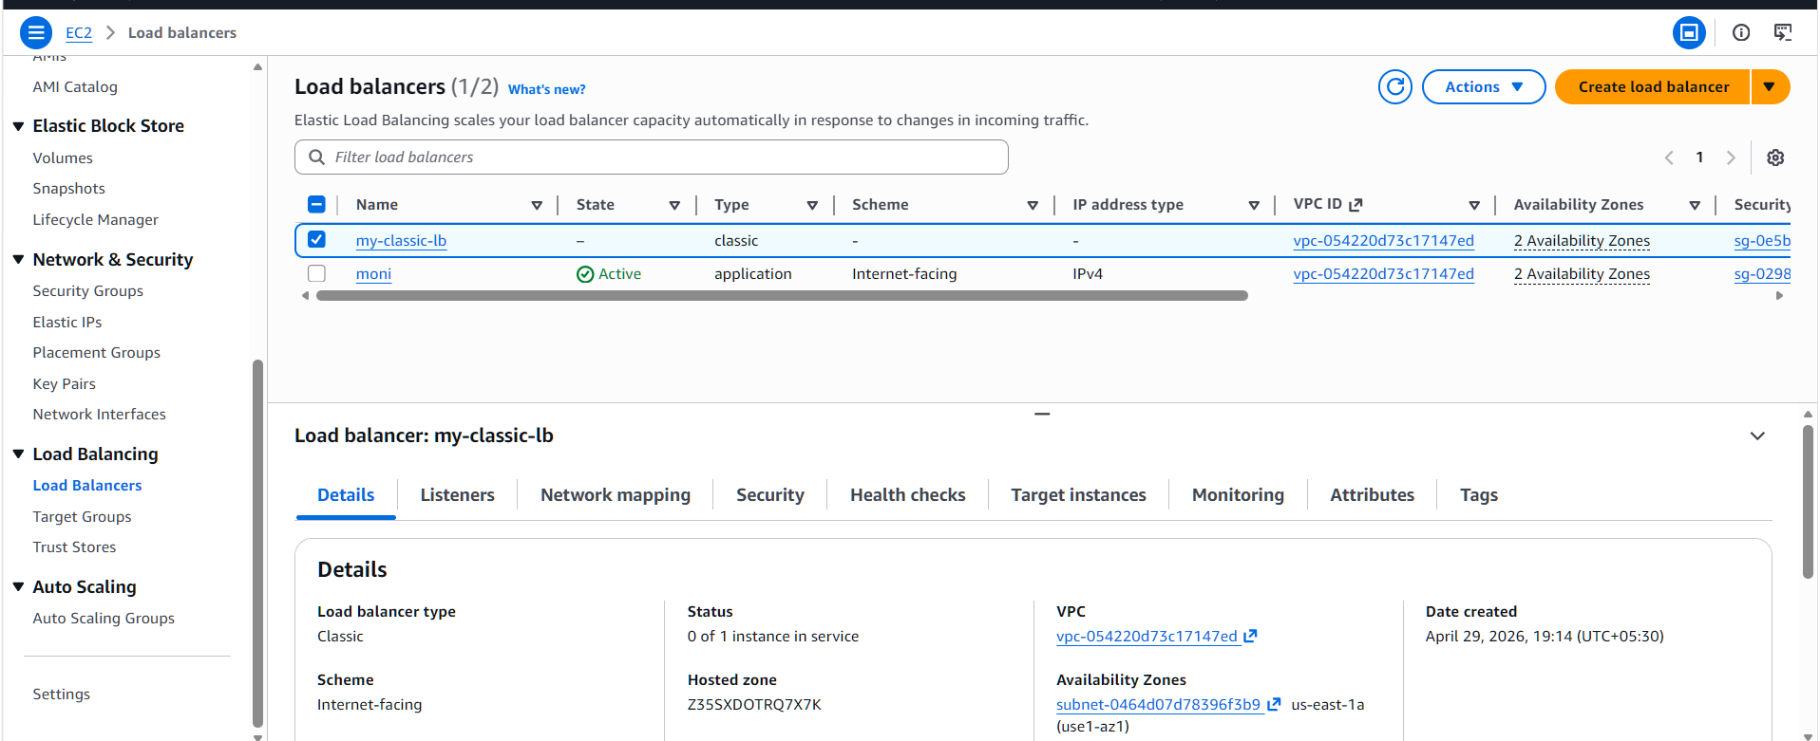
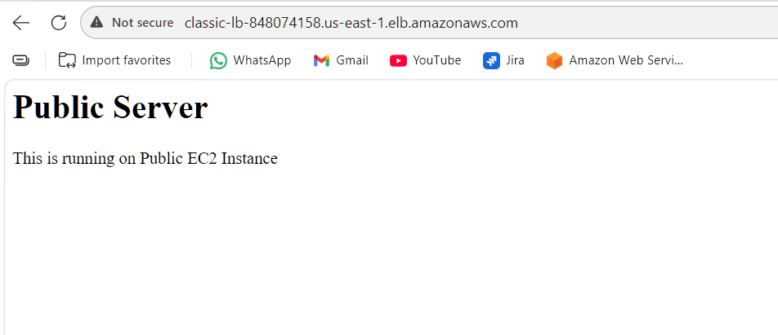
- Configure Application Load balancer.
Go to EC2 → Load Balancers
Click Create → Application Load Balancer
Enter name and choose Internet-facing
Select VPC and subnets
Add Listener (HTTP – Port 80)
Create Target Group
Register EC2 instances
Configure Security Group (allow port 80)
Click Create
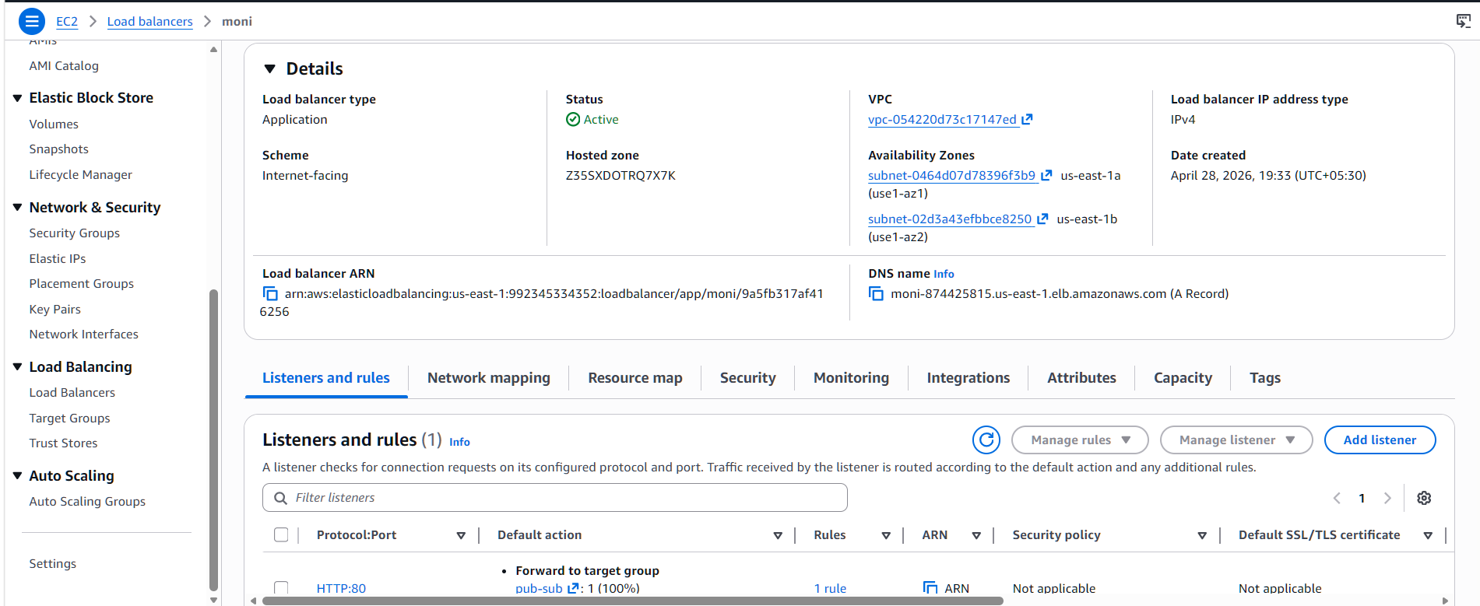
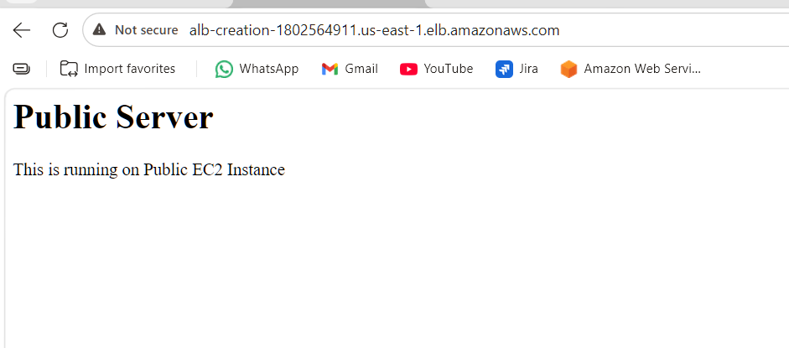
- Configure Network Load balancer.
Opened AWS Console and went to EC2 → Load Balancers.
Clicked Create Load Balancer and selected Network Load Balancer.
Entered name and chose Internet-facing.
Selected VPC and public subnets.
Set listener as TCP:80.
Created target group and registered EC2 instance.
Attached target group to NLB.
Created the load balancer.
Verified DNS endpoint.

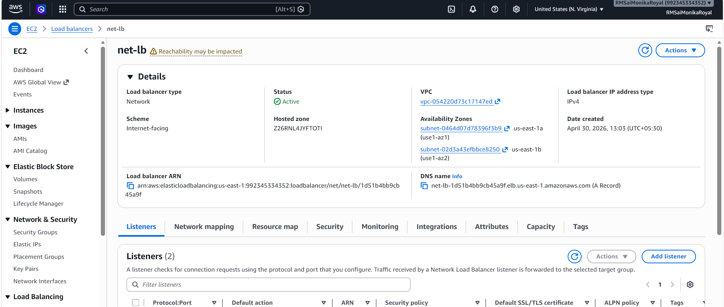
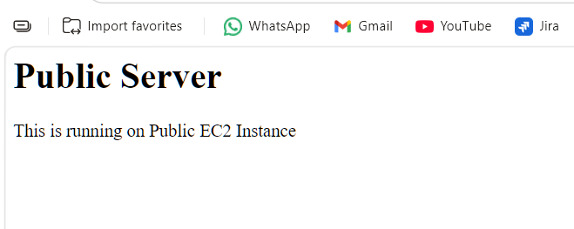
- Attach SSL for application load balancer.
- Map Application load balancer to R53.
Opened AWS Console and went to EC2 → Load Balancers.
Selected the Application Load Balancer.
Added a new listener with protocol HTTPS on port 443.
Selected SSL certificate from ACM.
Attached the certificate to the listener.
Forwarded traffic to the target group.
Saved the configuration.
Verified secure access using HTTPS URL.
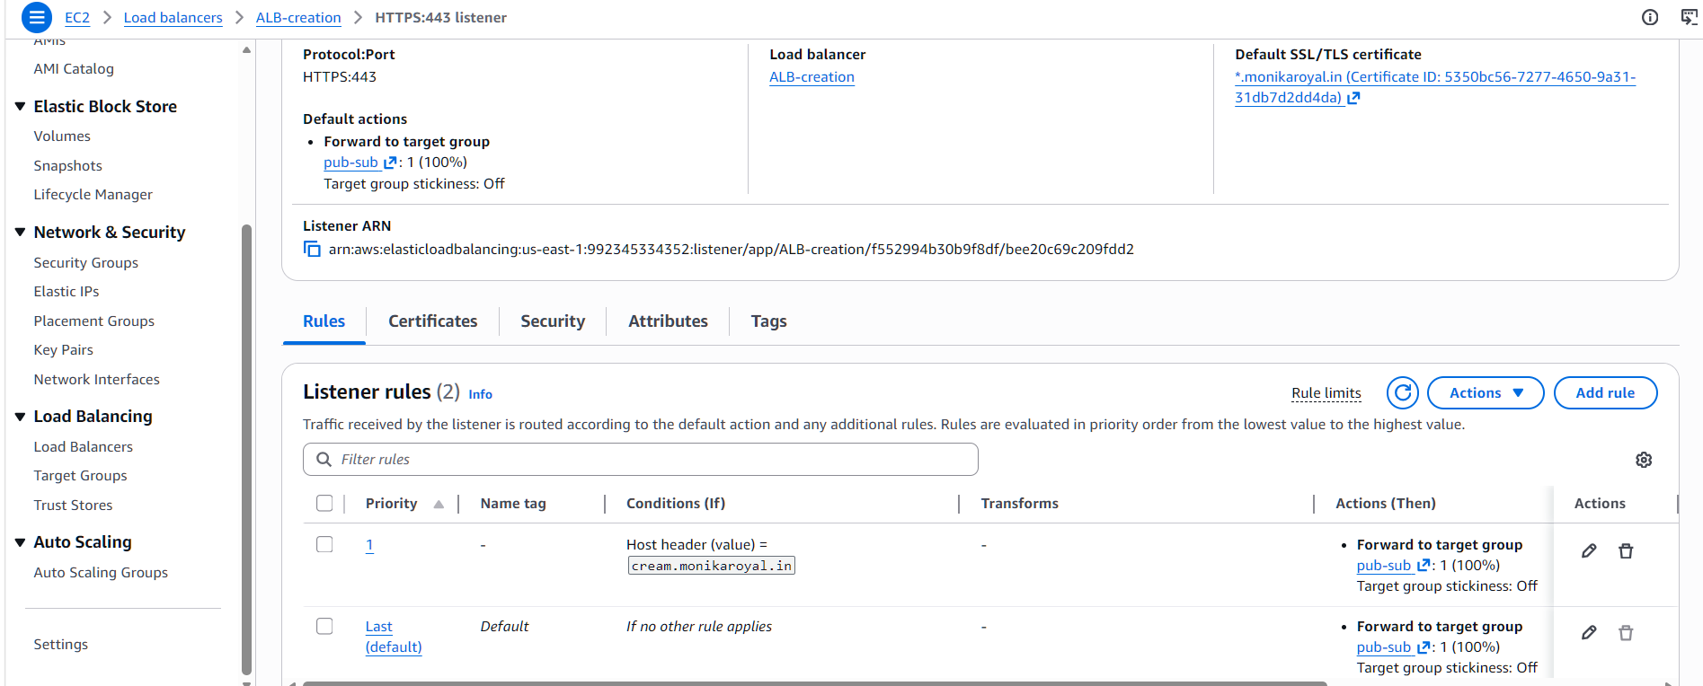
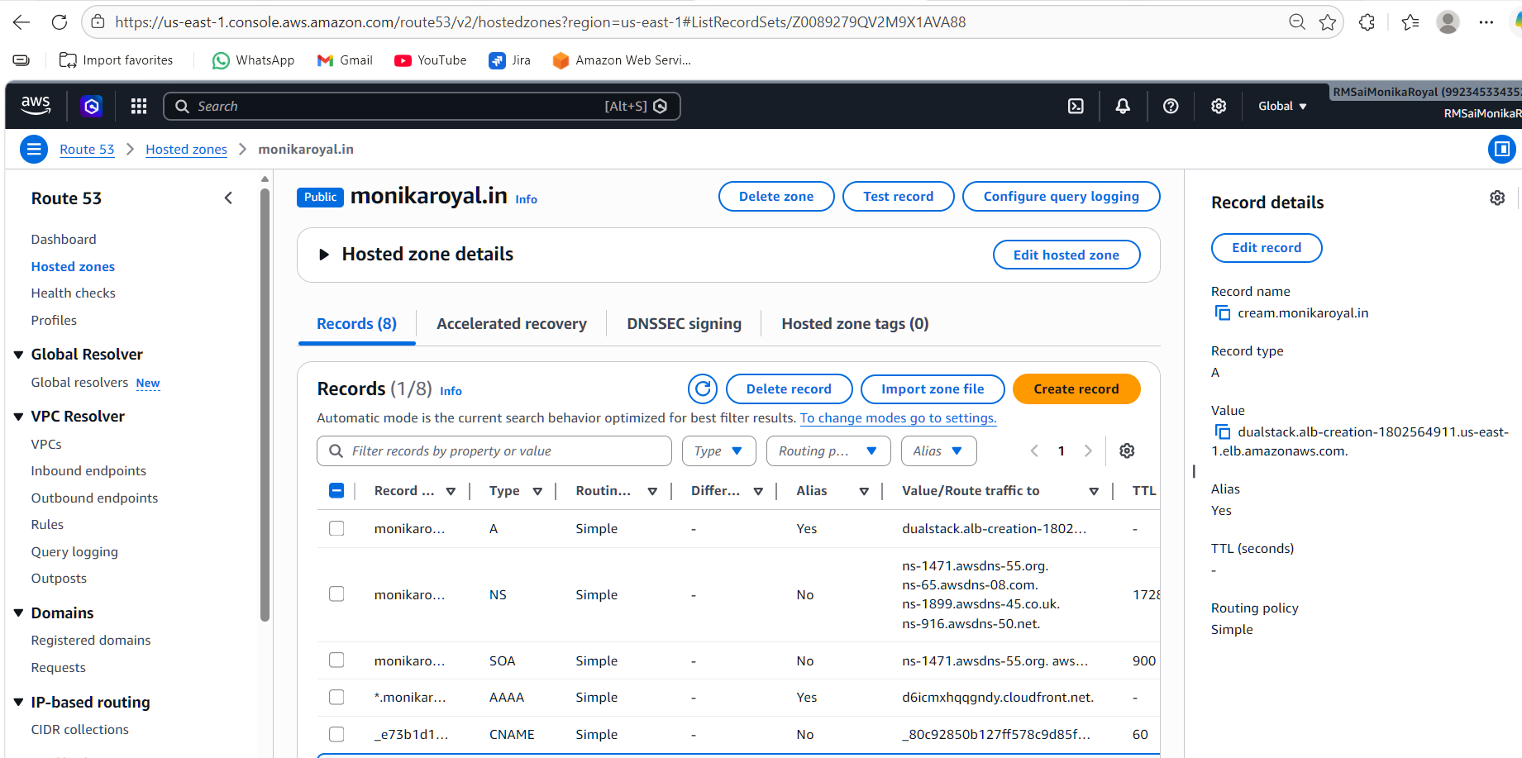
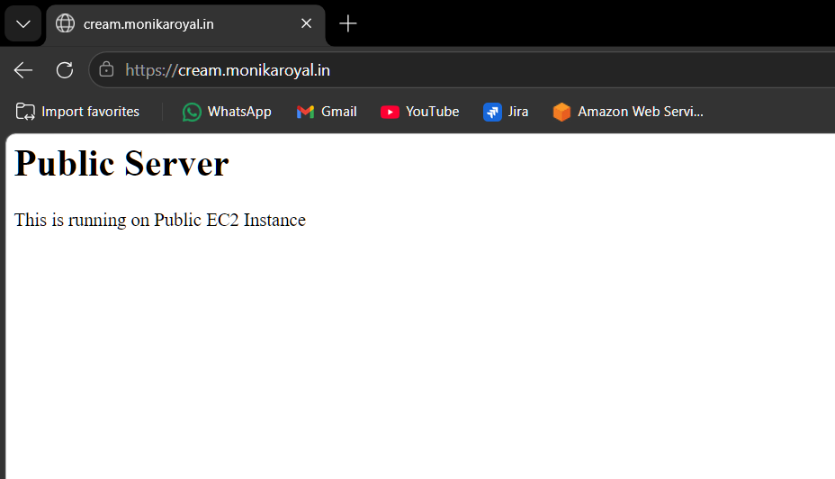

- Push the application load balancer logs to S3.
Created an S3 bucket (alb-logs-bucket-001) to store ALB logs.
Added bucket policy to allow ALB to write logs.
Enabled access logging in the Application Load Balancer.
Linked the S3 bucket to store logs.
Verified logs are generated and stored in the AWSLogs folder.
.
